Create a Folder with Windows

**Qwiklabs Overview**

In this IT Support Professional Certificate, we will be using a tool called Qwiklabs to simulate many of the real-world experiences you may encounter in a tech role. In this lab, you will familiarize yourself with the Qwiklabs platform and interact with a Windows virtual machine.

**Lab Introduction**

This lab will introduce you to the Qwiklabs online learning platform, powered by the Google Cloud Console. You’ll interact with Qwiklabs in lots of courses of the IT Support Professional Certificate program, so it’s important that you follow these instructions carefully. We’ll give you some background information about what Qwiklabs are, how these labs will help train you as an IT Support Specialist, and how to setup your Google Cloud Console via Qwiklabs. Finally, you’ll interact with the lab materials themselves. Ready? Let’s get started!

**What you’ll do**

There are two learning objectives for this lab:

* Familiarize yourself with the Qwiklabs environment and log into the Google Cloud Console.
* Access a Windows VM instance and create a basic file using the graphical user interface (GUI).

**You will have 60 minutes to complete this lab.**

Ans :

# **Create a Folder with Windows**

External IP address



username



password



**Introduction**

This lab will introduce you to the Qwiklabs online learning platform. You'll interact with Qwiklabs in lots of courses of the IT Support Professional Certificate program, so it's important that you follow these instructions carefully. We'll give you some background information about what Qwiklabs are, and how these labs will help train you as an IT Support Specialist. Finally, you'll interact with the lab materials themselves. Ready? Let's get started!

**Head's up:** You'll experience a delay as the labs initially load (particularly for Windows labs). So, please **wait a couple of minutes for the labs to load**. Please also make sure to access the labs **directly through Coursera** and not in the Qwiklabs catalog. If you access the labs through the Qwiklabs catalog, you will *not* receive a grade. (As you know, a passing grade is required to matriculate through the course.) The grade is calculated when the lab is complete, so be sure to hit "**End Lab**" when you're done!

**What is Qwiklabs?**

**Qwiklabs** is an online learning environment that will take you through a live, real-world tech scenario that you may encounter as an IT Support Specialist. Qwiklabs "spin up," or create, virtual machines. A *virtual machine* (VM) is exactly how it sounds: it creates a "virtual" (rather than actual) simulation of software. As you've learned throughout the **Technical Support Fundamentals course**, the Windows operating system (OS) is just a piece of software. This way, you don't have to purchase this software to complete the courses in the IT Support Professional Certificate. This also allows you to use Windows OS as if it was installed on your local machine, so you can practice and familiarize yourself with this technology.

In this Qwiklab, you'll spin up a virtual machine of the Windows OS. In other Qwiklabs throughout the IT Support Professional Certificate, you may spin up other *instances* (or other occurrences) of software; Qwiklabs isn't just limited to operating systems. You'll soon learn that, with Qwiklabs, you can interact with many other real-world scenarios that you may see as an IT Support Specialist.

**Head's up:** Each Qwiklab will create temporary VM credentials that will last *only* for the duration of the lab. In other words, you'll need to connect VM for each Qwiklab offered in the IT Support Professional Certificate program.

**WARNING** - If it's your **second** attempt of this lab, close this tab and **go back to Coursera** and retry this lab by hitting the "Open Tool button" in order to get a full score for this attempt.

**Learning tip:**

Whenever possible, we encourage you to try these exercises on your local machines or home computers -- if that's an option for you! When you're learning something new for the first time, or you're trying to improve a skill that you already have, remember that "practice makes perfect." So, practice the skills you'll learn in the Qwiklabs as much as you can!

**What you'll do**

There are two learning objectives for this lab:

* Familiarize yourself with the Qwiklabs environment.
* Access a Windows VM instance and create a basic folder using the graphical user interface (GUI).

You'll have 60 minutes to complete this lab.

Start the lab

You'll need to start the lab before you can access the materials in the virtual machine OS. To do this, click the green “Start Lab” button at the top of the screen.

**Note:** For this lab you are going to access the **Windows VM** through your **local RDP Client**, and not use the **Google Console** (**Open GCP Console** button is not available for this lab).

Start Lab

After you click the “Start Lab” button, you will see all the connection details on the left-hand side of your screen. You should have a screen that looks like this:

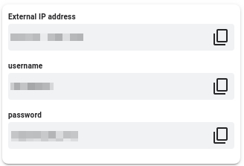

**Note:** Working with Qwiklabs may be similar to the work you'd perform as an IT Support Specialist; you'll be interfacing with a cutting-edge technology that requires multiple steps to access, and perhaps healthy doses of patience and persistence(!). You'll also be using **RDP** to enter the labs -- a critical skill in IT Support that you’ll be able to practice through the labs.

**Accessing the virtual machine**

Please find one of the four relevant options below based on your device's operating system.

Option 1: Windows Users: Connecting to your VM via RDP

In this section, you will use Remote Desktop Connection to connect to your windows instance using its external IP address.

1. Open Remote Desktop Connection by clicking the **Start** button. In the search box, type **Remote Desktop Connection**, and then, in the list of results, click Remote Desktop Connection.
2. Enter the external IP address of the instance you want to connect to in the **Computer** field. Find the external IP address for your instance from the Connection Details Panel on the left side. Click on **connect**.

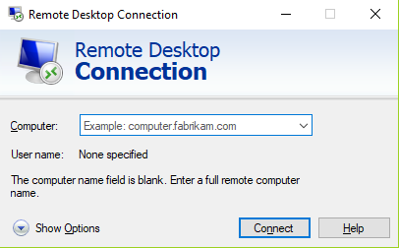

1. Change the username to **student**. And use the password mentioned in the Connection Details Panel on the left side. Click **OK**.
2. Click **Yes** to accept the certificate.

You should now see a visual interface that looks exactly like the Windows 10 OS!

If you see any error message, close the window and wait a minute or so. Sometimes the VM-creation process takes a few minutes, and you won't be able to access the VM until it's finished. This also applies to any errors that say your credentials (username and password) are incorrect.

Option 2: OS X users: Connecting to your VM via RDP

In this section, you will use Microsoft Remote Desktop 10 to connect to your windows instance using its external IP address. OSX users can [download Microsoft Remote Desktop from the Mac App Store](https://apps.apple.com/us/app/microsoft-remote-desktop-10/id1295203466?mt=12). If you are using Microsoft Remote Desktop 8, note that the interface will vary slightly than what’s listed below.

1. Open Microsoft Remote Desktop 10 application.
2. Click on **+** sign above, followed by **Add PC**.

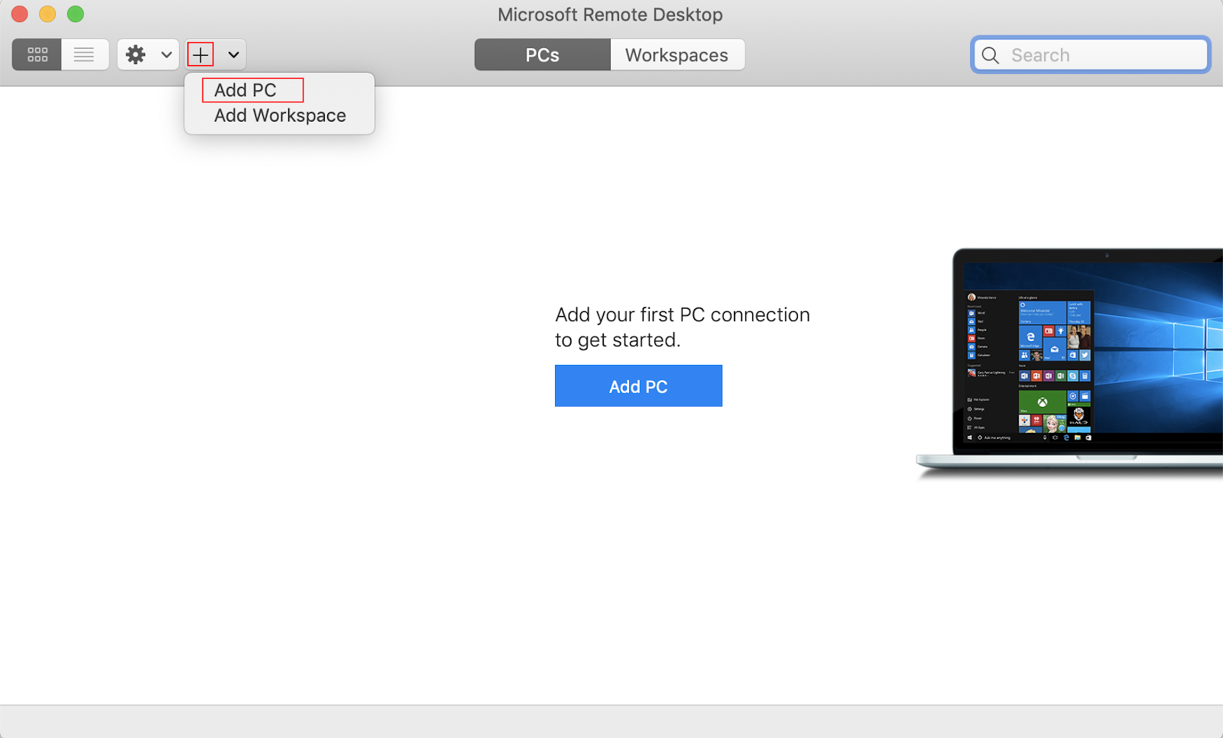

1. Enter the external IP address of the instance you want to connect to in the **PC name** field. Find the external IP address for your instance from the Connection Details Panel on the left side. Click on the **Add** button.

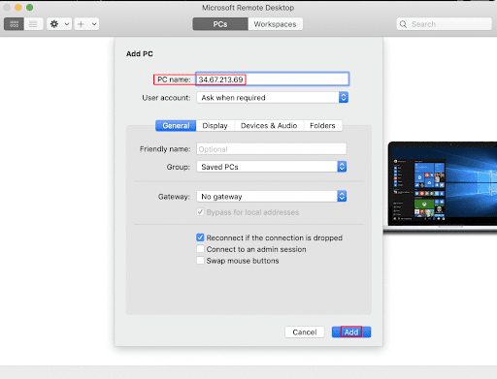

1. You should now be able to see your desktop represented by the external IP address of your VM instance under **PCs**. Double click on your VM’s external IP address.
2. The application will now prompt you for username and password. Change the username to **student**. And use the password mentioned in the Connection Details Panel on the left side. Once you have entered the details click **Continue**.
3. For any prompt regarding ‘Certificate verification’, click **continue**.

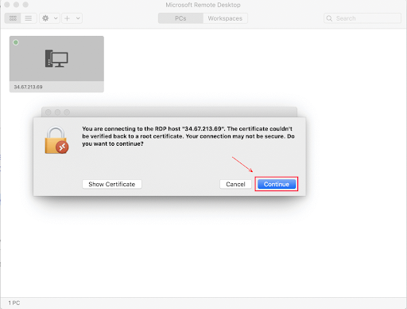

You should now see a visual interface that looks exactly like the Windows 10 OS!

If you see any error message, close the window and wait a minute or so. Sometimes the VM-creation process takes a few minutes, and you won't be able to access the VM until it's finished. This also applies to any errors that say your credentials (username and password) are incorrect.

Option 3: Chrome OS users: Connecting to your VM via RDP

In this section, you will use Chrome RDP to connect to your windows instance using its external IP address.

Chrome OS users can [download Chrome RDP from Chrome Web Store](https://chrome.google.com/webstore/detail/chrome-rdp/cbkkbcmdlboombapidmoeolnmdacpkch). Once you navigate to the download page, click on the **Add to Chrome** button. Click on **Add app** in case of any pop-ups. Then, click on **Launch app** to start the application.

1. Open the Chrome RDP application.
2. Enter the external IP address of the instance you want to connect to in the **Enter the computer name or address to connect to** field. Find the external IP address for your instance from the Connection Details Panel on the left side. Click on **connect**.
3. Leave the domain field blank. Change the username to **student**. And use the password mentioned in the Connection Details Panel on the left side. Click **OK**.
4. Click **Continue** for any window related to certificate verification.

You should now see a visual interface that looks exactly like the Windows 10 OS!

If you see any error message (an example of one is shown below), close RDP and wait a minute or so. Sometimes the VM-creation process takes a few minutes, and you won't be able to access the VM until it's finished. This also applies to any errors that say your credentials (username and password) are incorrect.

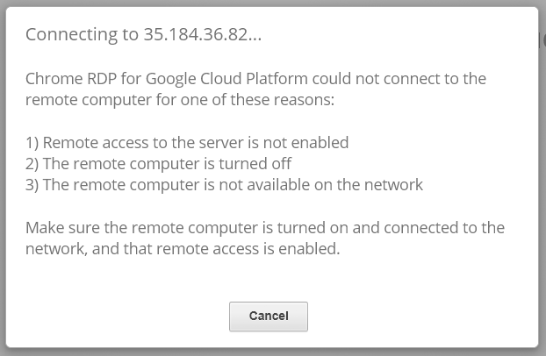

Option 4: Linux users: Connecting to your VM via RDP

In this section, you will use **Remmina** to connect to your windows instance using its external IP address. Open Remmina in your Linux machine. Linux users can [install Remmina](https://remmina.org/how-to-install-remmina/) if it is not pre-installed.

1. Open Remmina.
2. Enter the external IP address of the instance you want to connect to. Find the external IP address for your instance from the Connection Details Panel on the left side. Click on **Connect**.

Make sure the connection protocol is set to **RDP**, as shown in the image below:

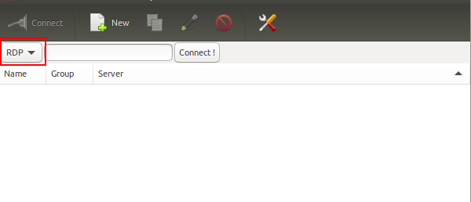

1. A window appears asking you accept the certificate, click **Ok** to continue.
2. Leave the domain field blank. Change the username to **student**. And use the password mentioned in the Connection Details Panel on the left side, for the **Password** field. Click **Ok** to continue.

You should now see a visual interface that looks exactly like the Windows 10 OS!

If you see any error message, close the window and wait a minute or so. Sometimes the VM-creation process takes a few minutes, and you won't be able to access the VM until it's finished. This also applies to any errors that say your credentials (username and password) are incorrect.

Using the Windows instance

Now you have access to the Windows instance, you're ready to start using it! This version of Windows is intended to be used on a Server, and auto-starts a server-management program. We don't need this for this lab, so wait for it to finish starting and then close it. You may see the desktop appear for a few seconds before the program launches.

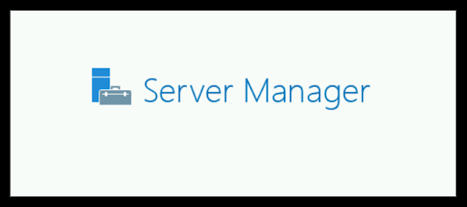 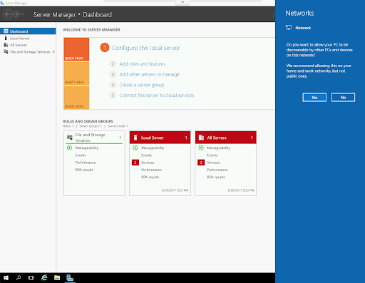

Once that's closed, the Windows OS is ready for you to use.

**Finishing the login process**

Now you‘ll see a Windows desktop background that looks like this:

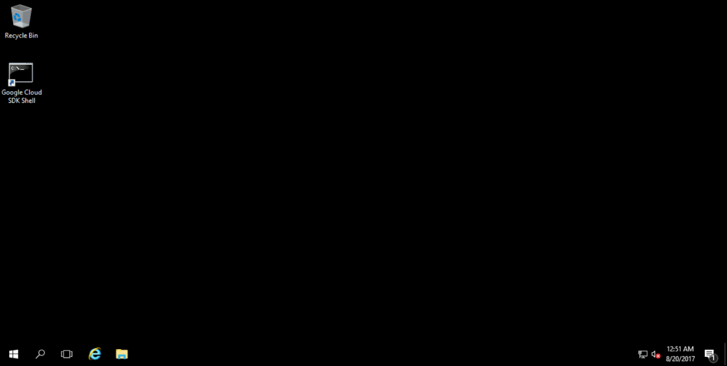

**Creating a folder**

Creating a folder in Windows is super simple. Right-click anywhere on the desktop and you should see this menu appear:

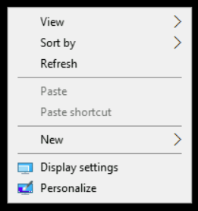

Hover your cursor over "New," and another menu should appear that looks like this:

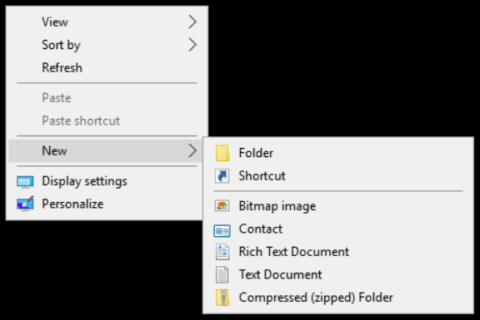

Move your cursor to the first option ("Folder"), and select it. If your cursor leaves the menus, they may disappear; if this happens, just repeat the steps again. A new folder should appear on the desktop. It'll be called "New folder" by default, and the text should already be highlighted for you to edit.

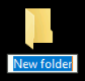

If you click anywhere before changing the name, you'll need to right-click the folder and select the **"Rename"** option to be able to edit it. Change the name to **"My Super Cool Folder"**.

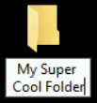 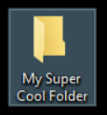

Your folder has been created and named! To verify, double-click on the folder and a Windows Explorer window should pop up, showing you the contents of your currently empty folder.

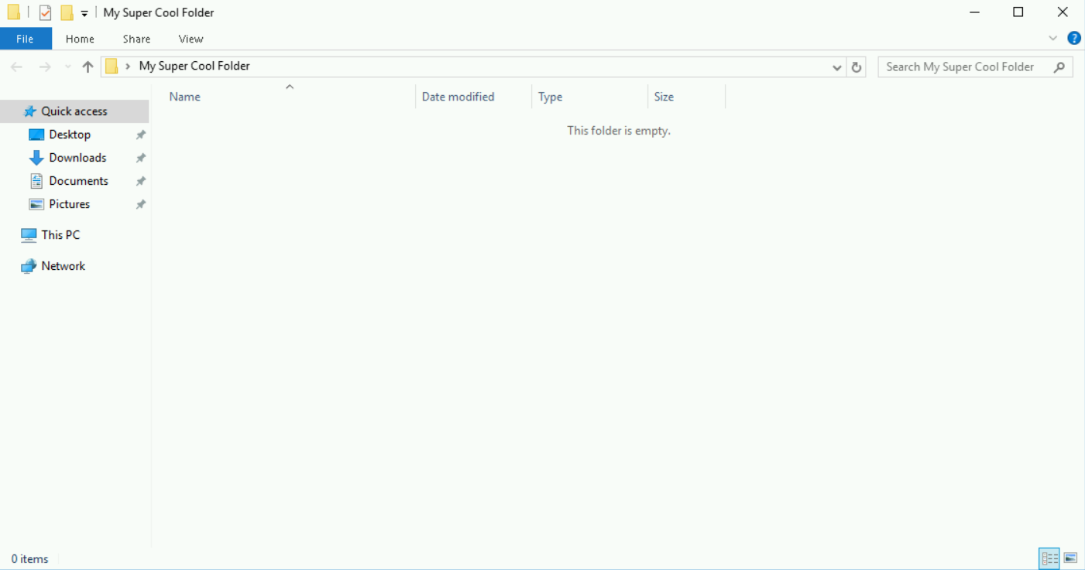

Click *Check my progress* to verify the objective.

Create a folder

Check my progress

**Congratulations!**

That's it! You've successfully accessed a Windows virtual machine using an RDP connection, and created a folder in the instance. There will be much more interesting labs to come, but the steps of connecting to Windows instances will remain the same. So, feel free to use this lab as a refresher if you ever forget the process.

You can now close the RDP/SSH window. You can manually end the lab, or it will automatically end when the time runs out.